**BME 313L: Introduction to Numerical Methods in Biomedical Engineering**

**Lab Report**

**Lab #9 Chapter 17: Polynomial Interpolation**

**Last name, First name:**

**EID:**

**Lab Section: Tuesday, Wednesday, Thursday, Friday**

**Problem 1**

Bessel functions often arise in advanced engineering analyses such as the study of electric fields. Here are some selected values for the zero-order Bessel function of the first kind

|  |  |  |  |  |  |
| --- | --- | --- | --- | --- | --- |
| $$x$$ | 1.8 | 2.0 | 2.2 | 2.4 | 2.6 |
| $$J_{1}(x)$$ | 0.5815 | 0.5767 | 0.5560 | 0.5202 | 0.4708 |

Estimate $J_{1}(2.1)$ using third and fourth-order interpolating polynomials with MATLAB’s built-in *polyfit* and *polyval*. Determine the percent relative error for each case based on the true value, which can be determined with *besselj*. Plot Bessel function of the first kind, and the polynomials you find for x=linspace(-2.6, 2.6, 50).

**Things to discuss** (100 word minimum for each question, 50 word minimum for discussing what you learned, what was reinforced)

(1) For 5 data points, there is one and only one polynomial of fourth-order that passes through all the points. Why?

(2) To attain the best possible accuracy for the estimates, the point should be centered around as close as possible to the unknown. Why?

(3) Do higher order polynomials always give better interpolations?

**Problem 2 from textbook Problem 17.5**

Given the data

|  |  |  |  |  |  |
| --- | --- | --- | --- | --- | --- |
| $$x$$ | 1 | 2 | 3 | 5 | 6 |
| $$f(x)$$ | 7 | 4 | 5.5 | 40 | 82 |

Calculate $f(4)$ using Newton’s interpolating polynomials of order 1 through 4 with function *Newtint*. Choose your base points to attain good accuracy. That is, the points should be centered around and as close as possible to the unknown. Repeat the problem using the Lagrange polynomial of order 1 through 4 with function *Lagrange.*

**Things to discuss** (100 word minimum for each question, 50 word minimum for discussing what you learned, what was reinforced)

(1) What do your results indicate regarding the order of the polynomial used to generate the data in the table?

(2) Which method could give you better accuracy in this problem?

**Problem 3 from textbook Problem 17.16**

The vertical stress σz under the corner of a rectangular area subjected to a uniform load of intensity q is given by the solution of Boussinesq’s equation:

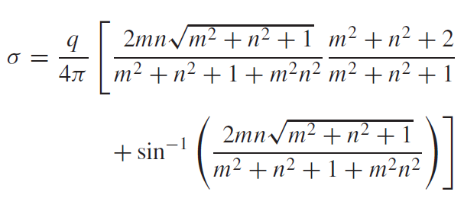

Because this equation is inconvenient to solve manually, it has been reformulated as



where fz(m, n) is called the influence value, and m and n are dimensionless ratios, with **m = a/z** and **n = b/z** and **a** and **b** are defined in Fig. 1. The influence value is then tabulated, a portion of which is given in Table 1. If a = 5.6 and b = 12, use a third-order interpolating polynomial to compute σz at a depth 10 m below the corner of a rectangular footing that is subject to a total load of 100 t (metric tons). Express your answer in tonnes per square meter. What is the vertical stress when (a, b) = (4.8, 14) or (4.2, 16) (the rest of parameters are fixed)? Note that q is equal to the load per area.

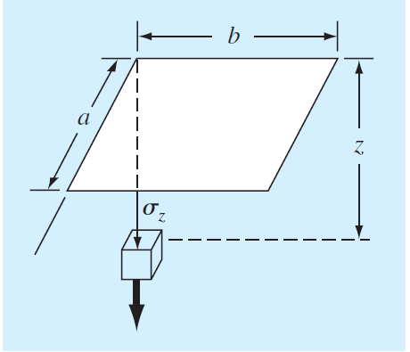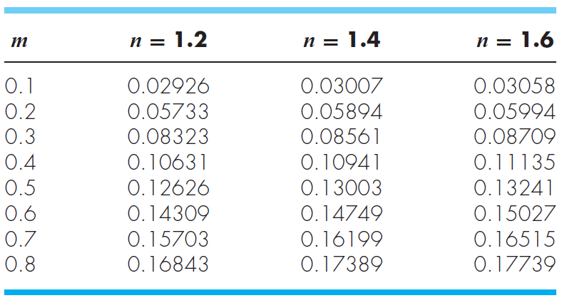

Table 1.

Fig. 1

**Things to discuss**

(100 word minimum for each question, 50 word minimum for discussing what you learned, what was reinforced)

(1) Discuss the relationship between aspect ratio of rectangular plate and vertical stress.